Your Best Access to Asian PCB Industry! -- Experience Magazine and Website altogether
Main Content
To increase buyer readership and ease of search, the purchasing guide has 3 main categories
- Product purchasing category search
- Professional articles and market news
- Product display advertisements
Publication item and method
First exposure will be made annually at the TPCA Show to provide visitors with a free index for PCB exhibitions globally.
The publication is free (all year) and they will be sent to:
- Purchasers at PCB suppliers in Taiwan and China.
- Local and foreign PCB industry associations.
- Global sales expansion teams.
Overview of main exhibitions
(The global exhibitions you can find PCB Shop)
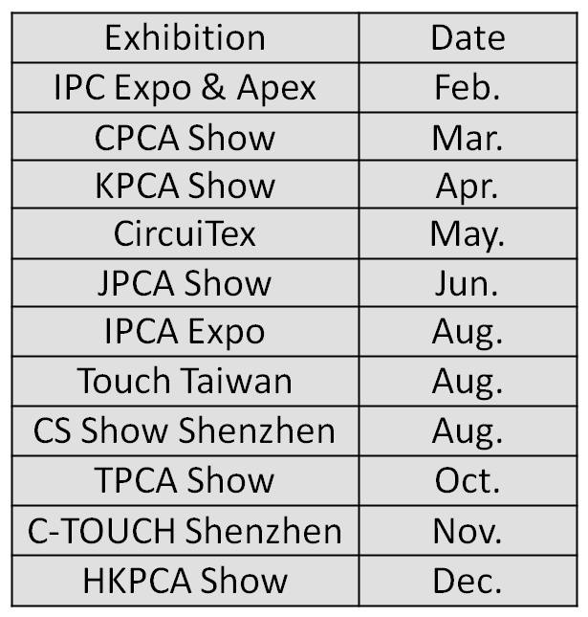
PCB Manufacturer Experiences
★Very helpful for purchasing.
- Shanghai Printronics Electronics
★Without even having to read this book, I know it will be helpful for those new in the industry.
-Guangda Technology (Guangzhou)
★Valuable for reducing costs in purchasing.
-Yi Ke Hua Electronics (Suzhou)
★Helpful for understanding related manufacturers.
-GuangZhou TaiHe Printed Circuit Board Limited
Publication and Circulation Fees (Size：19x26cm/page)
Layout |  | Starting Bid  (tax not included)
Special Page  ︵  Bidding Model  ︶ | Cover | US$6800
 | Cover 2 (inside cover, left) | US$4100
 | Inside cover 2 (right page of inside cover) | US$4700
 | Cover 3 (left) | US$3500
 | Above Index | US$2600
 | Bookmark | US$4600
 | Back Cover | US$5600
 | Inside Back Cover (right) | US$4100
 | Inside Back Cover (left) | US$3500
 | Pull-out page (4 pages total) | US$6100
 | 2-pages before column | US$2600
Single Page |  | NT$24700  (tax included)
Special page auction (5% tax not included): The auction will be priced in USD and the highest bidder wins. Members and previous clients have priority (previous clients retain publication priority, in the event of doubt the organizer’s definition will take priority)

Advertisement Method
This purchasing guide will be published on October of 2017(total 16,300 volumes) and deadline for advertisements is August 30th 2017. Clients will provide electronic files. CYMK color model must be provided. Layout specifications: 19cm x 26cm color page.
Special Advertisement Plans:
- More than 4 pages published, TPCA member: 20% Non-members: 10%
- 2~3 pages published, TPCA members 5% discount
For More PCBShop information visit www.PCBShop.org

Advertisement Application Form <This is seen as formal contract >
Company Name | (Chinese)
 | (English)
Company Address
Website
Tel |  | Fax
GUI |  | Contact
Contact Tel | Ext. | Cell phone
Contact E-mail |  | Price
2018 PCB SHOP | □single page: page(s) □special page-layout： （ex：Cover），  Size：19 x 26cm / page  *special page：Competitive Bidding：Priced in USD，the highest bidder wins.  Members and previous clients have priority。  □ I want to use TPCA coupon dollars (except special page)
 | □Manufacturing□Machines and Equipments□Chemicals and Base materials□energy saving & Public safety□intelligent automation□Others
Payment terms | 1、After receiving your application form, a payment request will be sent with bank transfer details
Note | 1. After receiving your application form, a payment request will be sent, please make the payment ASAP, invoice will be provided after the payment is made.  2. Members of TPCA will need a valid membership for discounts, if your membership expires before the publication date, your ads will not be published and fees will not be refunded.  3. Any request of cancellation or reduce of pages made after Sept 1st will not be refunded.  4. Price does not include photography and art for the advertisement.  5. Price does not include ad design, please contact advertising agencies if needed.  6. Advertiser is solely held responsible if any of the advertised product, logo or design that violates the laws of copyrights. PCBShop publisher disclaims all liability.  7. This application form will be viewed as formal contract, please fill in the form carefully.
Advertiser (Company seal) |  |  | Company representative (signature)
Advertiser Company Seal： |  |  | (Signer is authorized by the advertiser company as the legal representative)
Contact Person：(Taiwan) Tel:886-3-3815659 #304； Claire (claire@tpca.org.tw)

